**Stat 401 - Lab 8: Running many tests and fdr adjustment**

**Goals:** In this lab, we will see how to use the JMP response screening platform to do many tests and then calculate the fdr adjustment for each p-value.

As far as I can tell, JMP requires the raw data for each test.

We will use the manyY.csv data set. This is a made-up data set with 30 responses, each measured on 25 individuals per group, with two groups.

Download the manyY.csv file from the JMP or the datasets page and load it into JMP. Change the modeling type for the grp variable from continuous (blue ramp) to nominal (red bars). That is necessary because the grp values are 1 and 2, which JMP reads as a continuous variable (blue ramp) but we want to use grp to indicate groups (i.e., model as a nominal variable to indicate groups).

**Using the response screening platform:**

From the main menu, choose Analyze / Screening / Response Screening. That should open a window looking like:

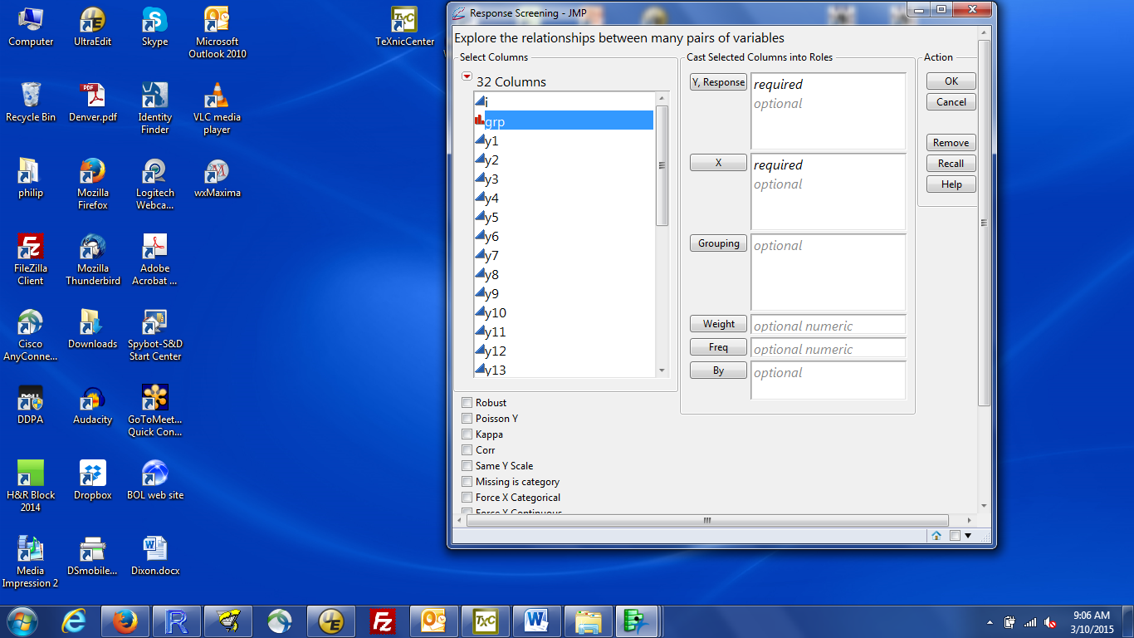

Notice that grp is red bars, because I want grp to indicate which of two groups each observation belongs to. If it is not red bars, close the analyze window, return to the data window and change the modeling type for grp to nominal.

Move grp to the X bos and all the response variables (y1 through y30) to the Y, Response box. You can use the usual Windows shift-click to select the entire range of responses at once.

Click OK to run the analysis

**Output from the response screening platform**:

You should see a small window looking like:

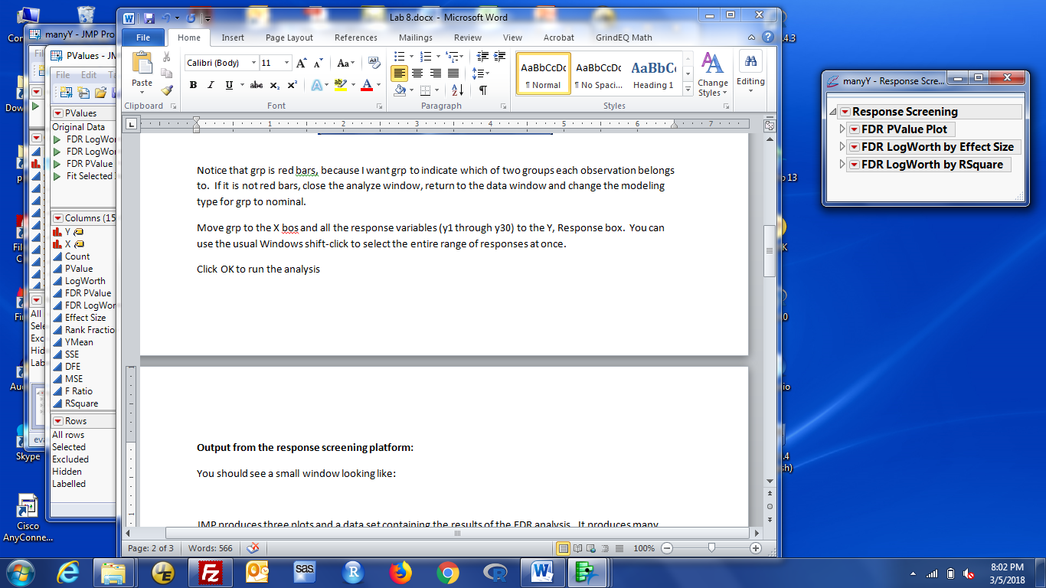

You should also see a new dataset window labeled PValues. If you don't see it on the screen, look in the JMP Home window (what you see when you first start JMP). The Window List (right hand panel) lists all the JMP windows. You should see one labeled manyY (the name of the data set you started with), with an analysis shown below it, and one labeled PValues. JMP produces many more numbers than we need. For this class, the only relevant results are the PValue plot and the FDR p-value column in the pvalues data set.

The little grey triangles to the left of each title in the above window allow you to see or hide a particular result. (This is true for any JMP result, we just haven't needed it until know). To see the PValue plot, click on the grey triangle (Not the more obvious red triangle) by FDR PValue Plot. The plot should look like this:

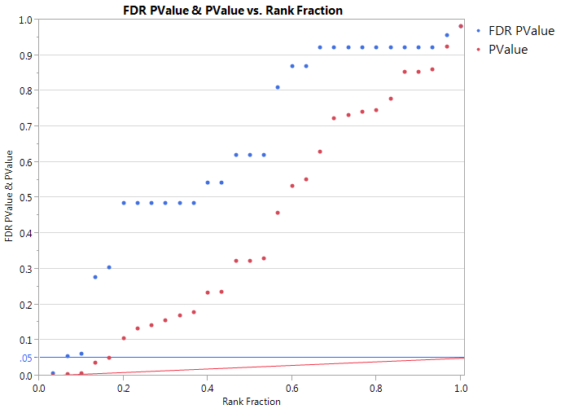

The X axis is arranges the responses from the one with the smallest p-value to the one with the largest. The actual value for the X axis is i/N, where i is the position in the sorted list (1 = smallest, 2 = next smallest, … N = largest) and N is the number of responses. The red dots (PValue) are the unadjusted p-values from each test; the blue dots (FDR PValue) are the FDR adjusted p-value for each test. JMP draws a line at 0.05 = 5% for your reference.

For these data, we see there are 5 tests with unadjusted p-values below (or approximately at) 5% and 1 test with an adjusted p-value less than 5%.

To see which tests have a specific p-value or range of p-values, click in the graph window to make it active, hold down the left mouse button and drag the mouse over the points of interest. You will see the selection rectangle on the graph as you move the mouse. The selected points are highlighted in the graph and also in the data table. Move to the PValue data table and you will see the highlighted rows for tests with the selected p-values.

If you want to see all the details of the test for each response variable, they are in the PValues data table. For our purposes, the two important columns are Pvalue (unadjusted p-value) and FDR pvalue (FDR adjusted p-value).

If you want to sort the P value table by FDR adjusted p-value, click on the PValues table to make it active, then select Tables / Sort, select FDR PValue column, and click By to move that column name into the sort by box. The two grey hashed triangles below the By box control the sort order (point up is from smallest to largest, i.e. increasing going down; point down is largest to smallest (i.e. decreasing going down). If you want to change the order, click on the variable name in the By box and then on the desired sort order. Then click OK.